Discuss Simulations that are conducted post initial application

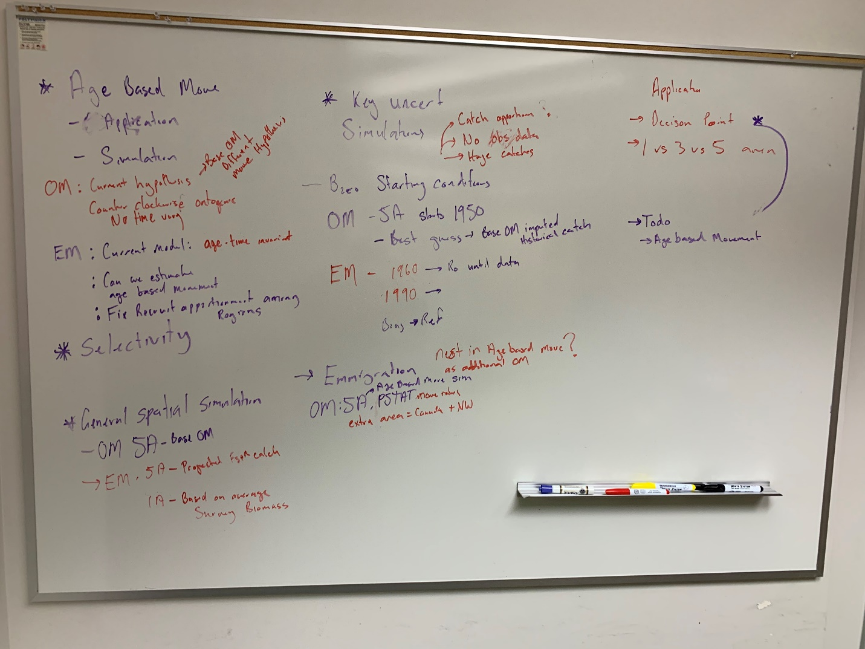

**Staring conditions and implications on Bzero and other reference points**

Large-scale commercial fisheries commonly larger catches early in the time-series as fisheries develop and modernize and science/management lagged (reference that hilborn paper). Historical catches are frequently reported at granular spatial and sometimes lack gear type information. This uncertainty in historical catch coupled with earlier periods generally lacking robust data monitoring programs, results in stock assessment starting conditions being potentially influential when providing management advice. This is a common phenomenon for stock assessments, and amplified when considering spatially explicit stock assessment models.

These characteristics lead to uncertainty in starting conditions for a stock assessment (references), but are amplified in spatially explicit stock assessment models.

Methods commonly applied to address this issue include, imputing the catch allocation back in time for each fleet and region and starting the model at or near an equilibrium age-structure. Another approach is to start the model later in the time-series with a non-equilibrium age-structure.

The concern with the later approach is historical periods contain large catches which can be a useful source of information on stock production (Hilborn & Magnusson & Hilborn). Our particular concern with this problem relates to our estimates of Bzero and thus depletion based reference points. This concern was raised due to the discrepancy between the current stock assessment model and our spatial models.

To explore this uncertainty we took our base 5A OM and extrapolated catches back to the 1960’s when large scale fishing occurred (reference). This OM simulated 500 data sets which assumed stochastic recruitment in each iteration which were each fitted to two EM’s. The first was a 5A EM which started in 1990 in a non-equilibrium age-structure the second EM was also a 5A model but used a simple imputation rule to allocate simulated catch and then used to estimate.

We focused on estimates of Bzero and reference points to compare performance among each EM and the OM.

**Questions:** non-equilibrium age-structure vary between regions? Currently I assume all regions have the same age-deviations from their respected equilibrium.

*Methods*

The operating model used was the base 5A OM (Supplementary~?), we used parameter estimates that were estimated from the application to inform parameter estimates from 1977-2019. Starting the OM from 1960 required assumptions regarding catch allocated to each region by gear and spatiotemporal recruitment.

The challenge with extending the current model beyond 1977 was allocating historical catch to regions. Two OMs were configured which differed by how historical catch was allocated in each region. The first OM (OM1) allocated historic catch by regions by using the average spatial distribution from all years in the time series for each fishery. The second OM (OM2) allocated historic catch by regions by using the average spatial distribution from the first five years in the time series (1977-1981) for each fishery. Both scenarios resulted in similar regional apportionment, with the only difference being the trawl fishery, which differed between BS and CGOA regions (see Figure 1)

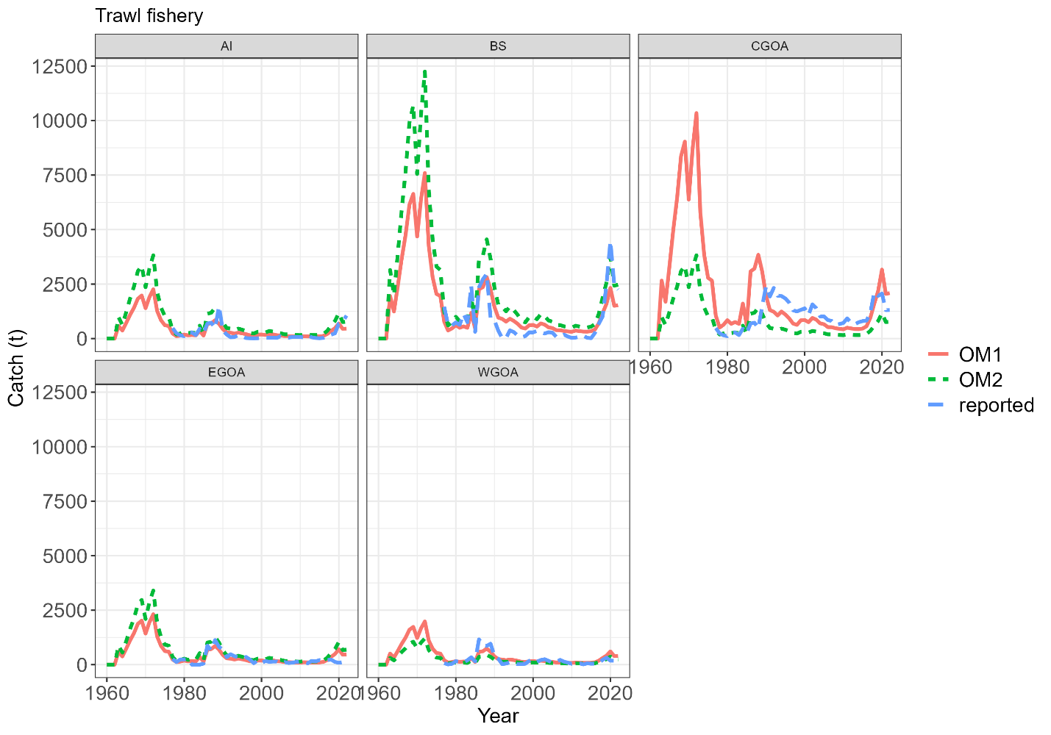

Figure : Allocated catch over the full time-series between OM1, OM2 and the reported catch for the trawl. Simulations only used OM catches prior to 1977 during simulations, otherwise the reported catch was assumed. A full time-series is plotted to assess allocation rules with reported data.

We applied the following algorithm to generate a simulated data set,

1. Generate parameters using the MLE estimates and covariance $θ_{sim}\sim MVN\left({\hat{θ}}_{MLE}, {\hat{Σ}}_{MLE}\right)$,
2. Simulate regional recruitment deviations for years 1960-1976 $ε_{r,y}\sim N\left(0,σ_{R}^{2}\right)$,
3. Run OM with all generated parameters and an imputed catch scenario for 1960-1976 and reported catch ,from 1977-2019,
4. Simulate observations.

We ran the algorithm 250 times for each imputed catch scenario (two OM scenarios). Three Estimation models were applied to each simulated data set. EM1 ran back in time and used imputation rule from S1, EM2 was the same but used imputed S2, and EM3 started the model in 1977 and attempted to estimate.

The aim of this simulation was to explore the effect of initial conditions for spatial models. Is it possible to estimate an Initial fishing mortality and non-equilibrium age-structure, or are we best to impute historical catches back in time and start models closer to equilibrium conditions.

Early simulations using historical catch and randomized recruitment found many OM simulations

*Results*

**Length-based movement investigation**

There is evidence from recent studies (Hanselman et al. 2015 & Maloney & Sigler 2008) and in the tag-recapture data (Figure 2) that different life-stages exhibit different movement patterns. More specifically, younger and smaller fish move north, older and larger fish move south.

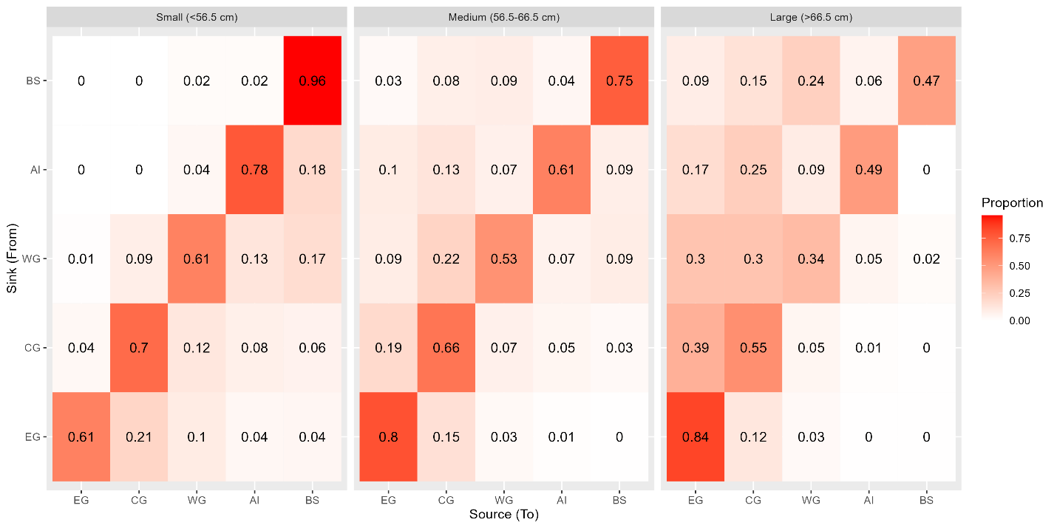

Figure : Movement rates derived for three different length groups (columns) for tagged fish that have been at liberty between 150 and 530 days (half a year to a year and a half).

To explore how robust our spatial model was to this movement dynamic, we conducted a simulation experiment using an agent-based operating model. We chose an agent-based OM for its ability to simulate realistic tag-recapture data.

Can we corroborate this length based trend in Survey LF data. i.e. BS and AI dominated by small fish. Because big fish have a tendance to move out and small fish stay. Might be confounded with movement and regional production.

Plot scaled LFs by regions to check this pattern.

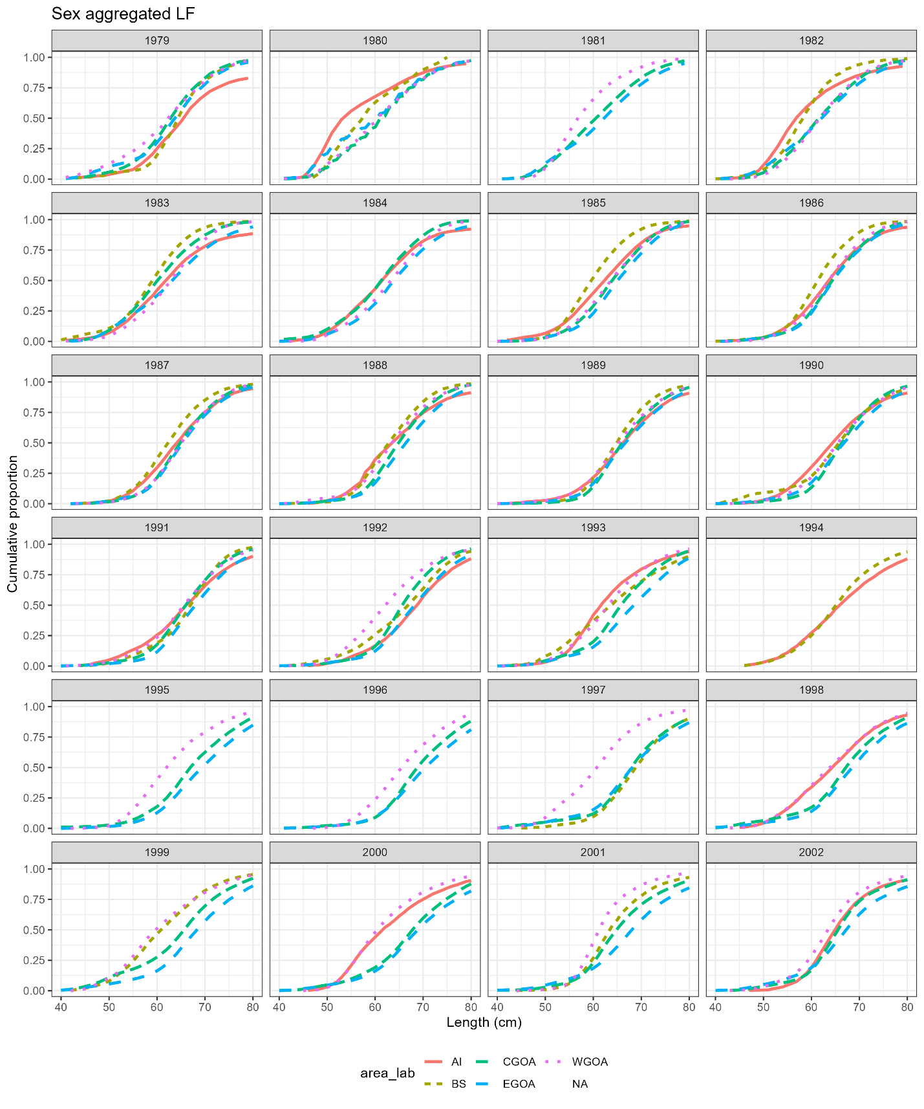

*Methods*

A five region agent-based OM was configured using CABM (C++ agent based model). The agent-based model used the movement rates from Figure 2. Summarizing tag-recapture data shown in Figure 2 assumes reporting rates and fishing mortality rates is constant over space. It assumed global recruitment with equal spatial apportionment among regions.

The problem with this was when I input the above movement rates in an ABM I get region SSB’s and age-structures that we don’t observe in the survey data.

The spatial assessment model (EM) does not assume movement differs between age and or length and we want to see the implications of this assumption given there is in fact true length-based movement.

**General spatial simulation**

Focus on catch apportionment 5A OM with a 1A EM and apportionment based on survey vs a 5A EM with projected SPR and depletion based reference points.

**Migration concerns**

Following on from the age-based clockwise movement investigation. We want to add an additional region in to the base 5A OM that represents NW and Canada based on movement rates estimated from the PSTAT research then look at the effect of closed populations and migrations.